Deliverable 2 – Health Analytics Project Design

Hui Xia  
hxia40@gatech.edu

CS-6440 – Introduction to Health Informatics

Georgia Institute of Technology

Feb 16th, 2020

# Clinical Question

Do patients that have been treated with Anagrelide have a higher risk of cancer, compared with a more conventional alternative, Hydroxyurea?

Note that in Deliverable 1, the clinical question was:

In patients undergoing treatment for thrombocythemia, does those that have been treated with Anagrelide has a higher risk of thrombosis, compared with a more conventional alternative, Hydroxyurea? However, the total number of concept records for such clinical question is limited. Thus, another valid clinical question is needed for this deliverable.

One of the driving force for the development of Anagrelide is that Hydroxyurea has been reported for being related with cancer risk. For example, Nand et. al. reported that hydroxyurea has 1–5.9% risk of causing leukemic transformation (Nand, Stock, Godwin, & Fisher, 1996). Hanft et. al. further suggested that in vivo hydroxyurea exposure could cause acquired DNA mutations (Hanft et al., 2000). Thus, whether such suggestions against hydroxyurea is reasonable, and whether the alternatives thereof, such as Anagrelide, could perform better in cancer risk, will need to be investigated.

# Patient Counts

* [hxia40] patients taking Anagrelide

<http://gt-health-analytics-1.us-east-1.elasticbeanstalk.com/#/cohortdefinition/446>

* [hxia40] patients taking Hydroxyurea

<http://gt-health-analytics-1.us-east-1.elasticbeanstalk.com/#/cohortdefinition/449>

* [hxia40] cancer patients exposed to either drug

<http://gt-health-analytics-1.us-east-1.elasticbeanstalk.com/#/cohortdefinition/452>

Patient counts in both datasets:

|  |  |  |  |
| --- | --- | --- | --- |
| Cohort | Patients taking Anagrelide | Patients taking Hydroxyurea | Cancer patients exposed to either drug |
| CMSDESynPUF100k | 638 | 699 | 172 |
| CMSDESynPUF23m | 20,392 | 15,774 | 4,801 |

# Incidence Rates

Among patients taking Anagrelide, 125.39/1,000 patients in the 100k dataset and 129.18/1000 patients in the 23m dataset were diagnosed with cancer. The incidence rates per 1k years are 103.49 and 102.95. Among patients taking Hydroxyurea, 133.05/1000 in the 100k dataset and 138.92/1000 patients in the 23m dataset were diagnosed with cancer. The incidence rates per thousand years are 103.79 and 108.68. Results are shown as below:

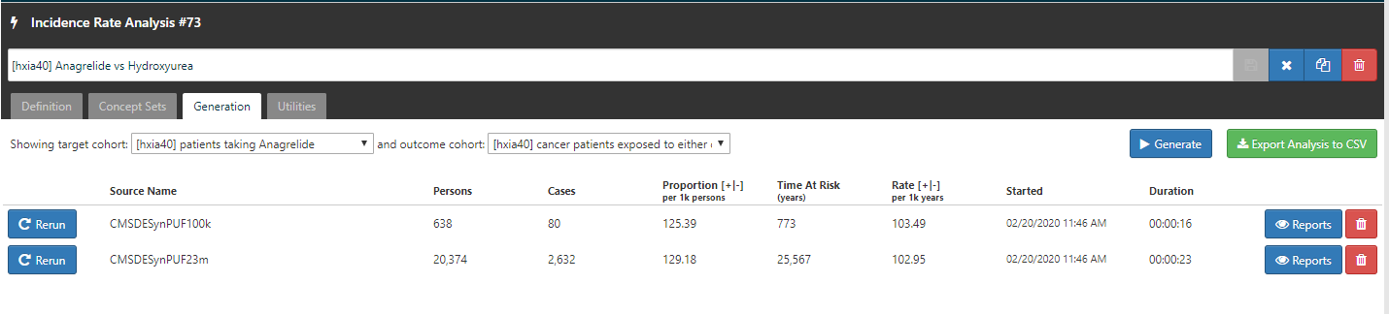

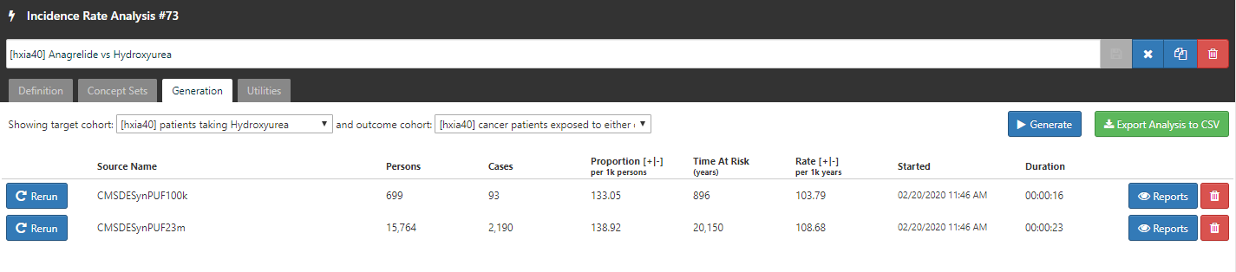

<http://gt-health-analytics-1.us-east-1.elasticbeanstalk.com/#/iranalysis/73>

# Cohort Characterization

<http://gt-health-analytics-1.us-east-1.elasticbeanstalk.com/#/cc/characterizations/65/design>

# Stretch Points:

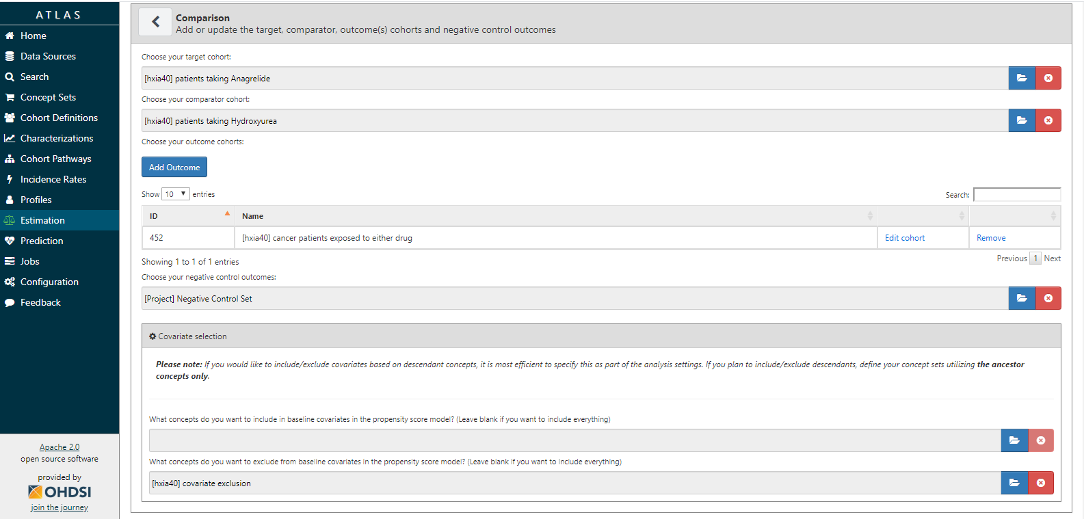

Covariate Exclusion, link is provided below

Negative control

O

C

T

[hxia40] covariate exclusion:

[<http://gt-health-analytics-1.us-east-1.elasticbeanstalk.com/#/conceptset/799/conceptset-expression>](http://gt-health-analytics-1.us-east-1.elasticbeanstalk.com/#/conceptset/799/conceptset-expression)

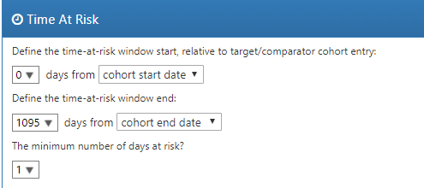

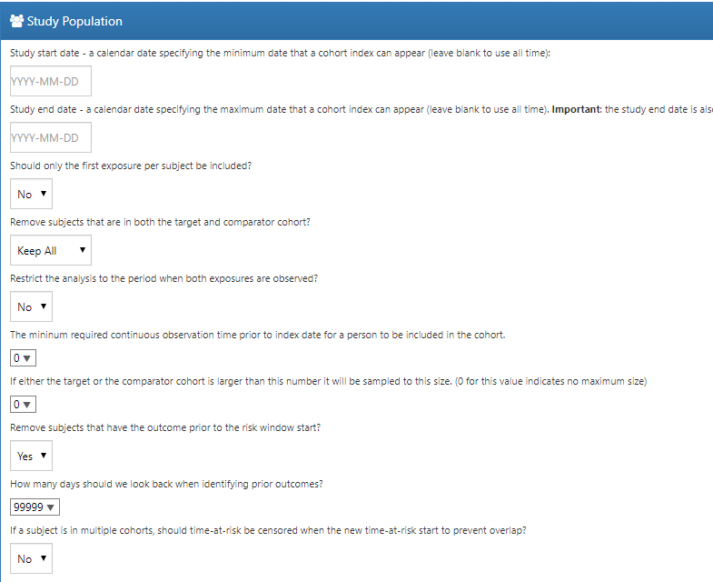

Remove subjects with prior events

Below is the result I got from estimation study analysis in RStudio. The patient counts for target and comparator cohorts are 634 and 691. The incidence rates are 103.15 and 103.56, accordingly. There numbers are similar to what I got by estimation analysis at Atlas.

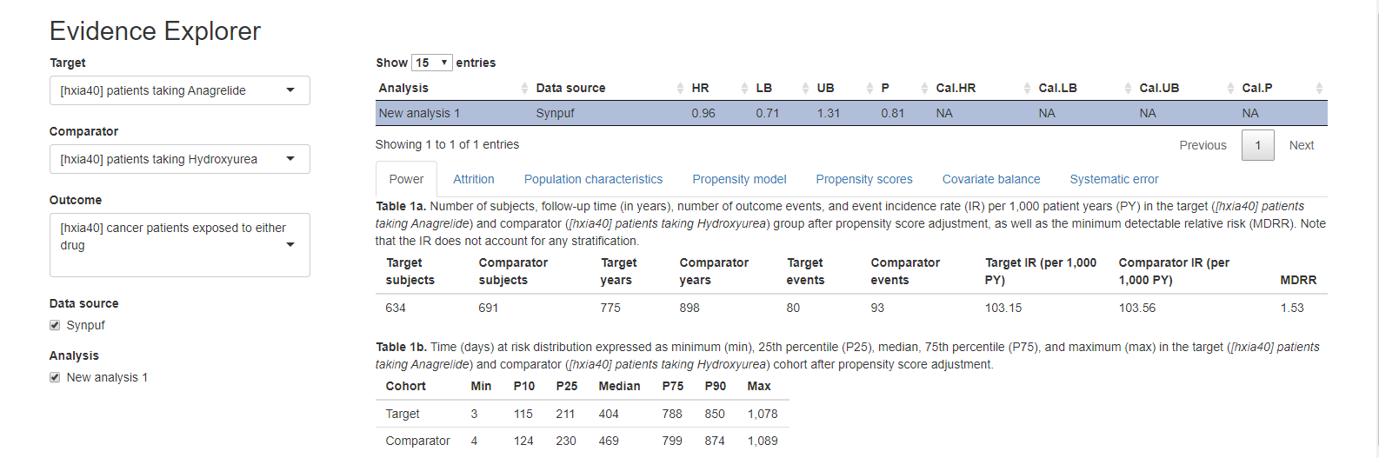

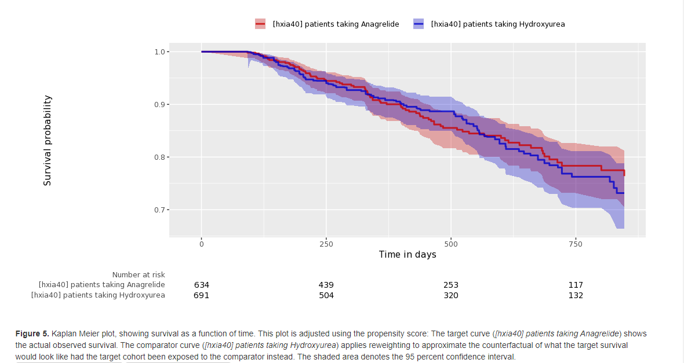

# References

2020 ICD-10-CM Diagnosis Code Z79.02. (2020). Retrieved from <https://www.icd10data.com/ICD10CM/Codes/Z00-Z99/Z77-Z99/Z79-/Z79.02>

DRUG: Hydroxyurea. Retrieved from <https://www.genome.jp/dbget-bin/www_bget?dr:D00341>

Hanft, V. N., Fruchtman, S. R., Pickens, C. V., Rosse, W. F., Howard, T. A., & Ware, R. E. (2000). Acquired DNA mutations associated with in vivo hydroxyurea exposure. *Blood, 95*(11), 3589-3593.

Nand, S., Stock, W., Godwin, J., & Fisher, S. G. (1996). Leukemogenic risk of hydroxyurea therapy in polycythemia vera, essential thrombocythemia, and myeloid metaplasia with myelofibrosis. *American journal of hematology, 52*(1), 42-46.